SIMATS ENGINEERING (SAVEETHA SCHOOL OF ENGINEERING)
Department of Computer Science and Engineering

ASSESSMENT TOOL 2 – Pseudocode Writing Task

Course Code: | CSA06 | Course Title: | Design and Analysis of Algorithms
CO Assessed: | CO5 – Naturalization (BL5, BL6) | Assessment: | Assessment Tool 2 –  Pseudocode Writing Task
Weightage: | 30% of CIA | Total Marks: | 100
CO5 Statement: | Analyze computational problems using backtracking techniques and complexity classes such as P, NP, NP-Hard, and NP-Complete for combinatorial problem solving.
Student Name: | N.Srinivas | Reg. No.: | 192372358
Section / Batch: | CSE(AI) | Date: | 25-08-2026

Instructions to Students
- Answer the following question with proper pseudocode and logical explanation.
- Clearly specify the algorithmic approach and complexity class wherever applicable.
- Use proper asymptotic notation (Big-O, Big-Θ, Big-Ω) for complexity analysis.
- Include state-space representation, recursion steps, and pruning conditions in backtracking problems.
- Neat presentation and step-by-step justification are mandatory.

Question Type | Focus Area | Questions
Pseudocode Writing Task | Analyze combinatorial problems using backtracking and complexity classes such as P, NP, NP-Hard, and NP-Complete. | Q1

SECTION A – Pseudocode Writing Task

Code of Conduct
I N.Srinivas(192372358) (Name / Reg No) certify that this submission is my original work and that I have adhered to the guidelines specified for this assessment. I understand that any violation of academic integrity rules will result in disciplinary action.
Signature of the Student: _n.srinivas________________________

RUBRICS FOR CALCULATION

Criteria | Weight age | Level 4 –  Exemplary | Level 3 –  Proficient | Level 2 –  Developing | Level 1 –  Beginning
Problem  Understanding | 20% | Identifies all inputs, outputs, constraints accurately | Minor missing elements | Partial understanding | Incorrect interpretation
Algorithm Design | 30% | Complete, correct, and logically sound solution | Minor logical gaps | Partially correct logic | Incorrect approach
Use of Control Structures | 20% | Efficient and appropriate use of loops, conditions, functions/modules | Minor inefficiencies | Limited or basic usage | Incorrect or missing constructs
Pseudocode  Structure | 10% | Well-structured, clear, consistent format, easy to follow | Mostly clear with minor issues | Difficult to follow in parts | Poorly structured and unclear
Completeness | 20% | Handles all cases; optimized approach | Handles most cases; reasonable efficiency | Handles basic cases only | Incomplete or inefficient
Criteria | Wt. | Level 4 –  Exemplary | Level 3 –  Proficient | Level 2 –  Developing | Level 1 –  Beginning
Problem Understanding | 20%
Algorithm Design | 30%
Use of Control Structures | 20%
Pseudocode Structure | 10%
Completeness | 20%
Total Marks (100):

Marks Evaluation:

Faculty In-charge | Course Coordinator | Head of Department
Name: | Name: | Name:
Signature: _______________ | Signature: _______________ | Signature: _______________
Date: ___________________ | Date: ___________________ | Date: ___________________

QUESTION AND ANSWERS:-

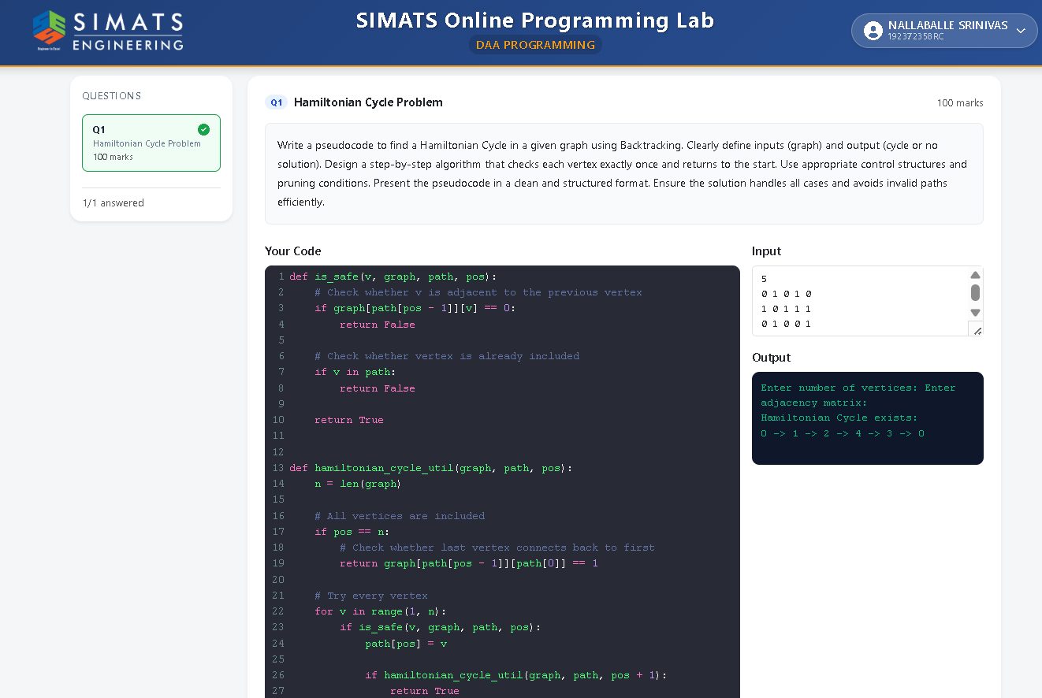
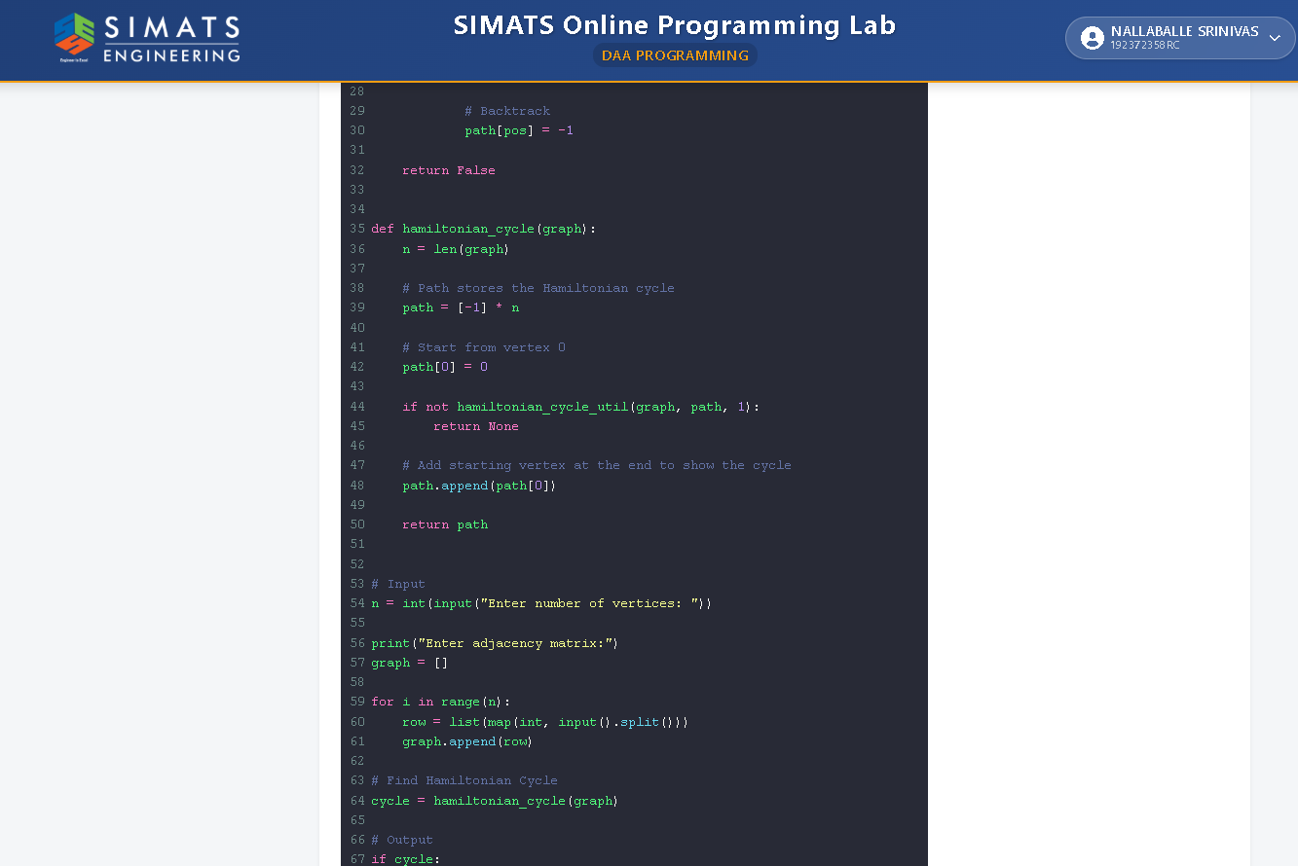

HAMILTON CYCLE PROBLEM:-
The Hamilton Cycle Problem is a graph theory problem that determines whether a graph contains a Hamiltonian cycle. A Hamiltonian cycle is a cycle that visits every vertex exactly once and returns to the starting vertex.

In this problem, a graph is given with a set of vertices and edges. The objective is to find a cycle that starts from a particular vertex, visits every other vertex exactly once, and finally returns to the starting vertex. Every vertex must be included in the cycle, and no vertex can be visited more than once except the starting vertex.

The Hamilton Cycle Problem can be solved using techniques such as Backtracking, Dynamic Programming, and Branch and Bound. Backtracking is commonly used by trying different paths and removing a path when it cannot produce a valid Hamiltonian cycle.

The problem is an important NP-complete problem, which means that finding a solution can become computationally difficult as the number of vertices increases. It is closely related to the Travelling Salesman Problem (TSP), where the goal is to find the minimum-cost Hamiltonian cycle.

Hamiltonian cycles have applications in network design, routing, scheduling, circuit design, and transportation planning. They are useful for finding routes where every location or node must be visited exactly once.

In conclusion, the Hamilton Cycle Problem is an important graph problem that focuses on finding a cycle containing every vertex exactly once and returning to the starting vertex. It is widely studied in computer science because of its applications in optimization and complex routing problems.

-------------------

